- Abstract
- Introduction

- Materials and Methods
  - Lit searching
  - Mapping/plotting/coding intro
  - Searched for pufa genes
  - Made gene diagrams/phylogenetic trees
  - Calculated global protein properties and protein ratios
  - Made homology models/started positive patch work
  - Did machine learning with global properties
  - Extracted residues from specific feature sets
  - Did machine learning with feature sets (categorical and regression) to predict optimal temperature
  - Looked at important residues for prediction and formed possible experiments using mutant library and others
- Results
- Future directions/planned experiments
- Figures
  - Figures describing dataset
    - 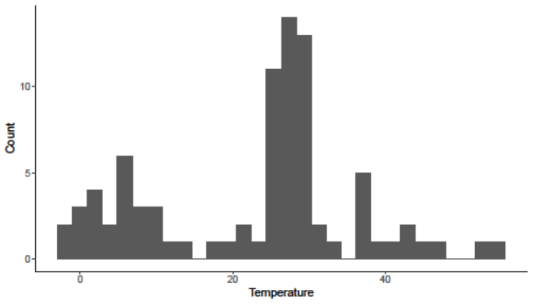
    - 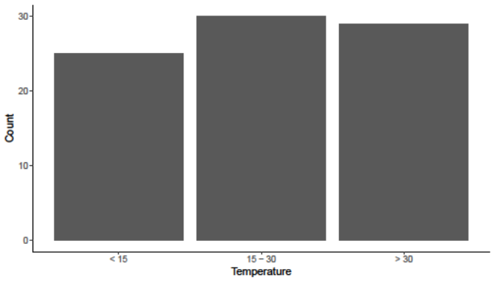
    - 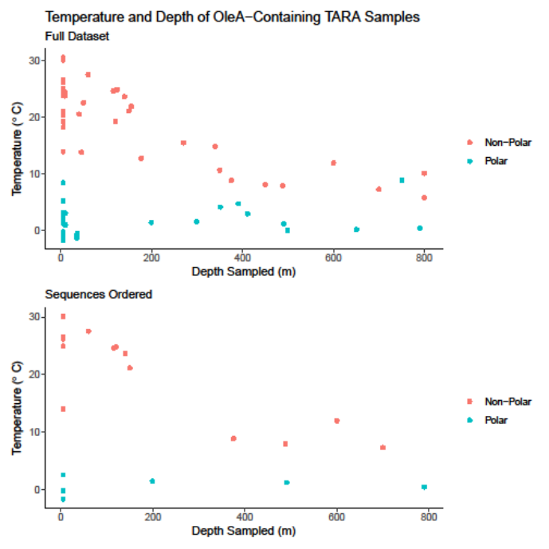
    - 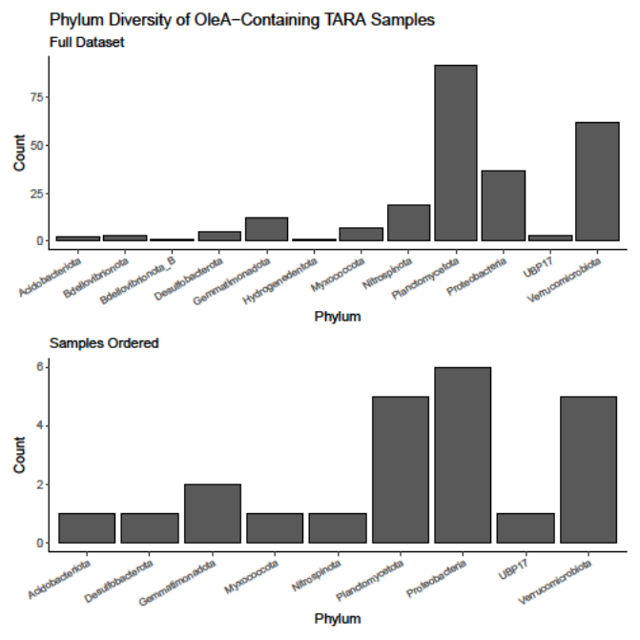
    - 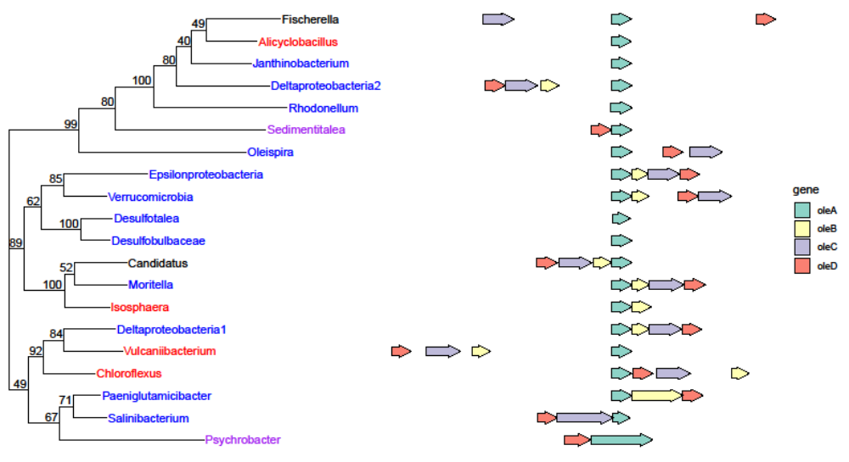
  - Feature analysis
    - Channel logo A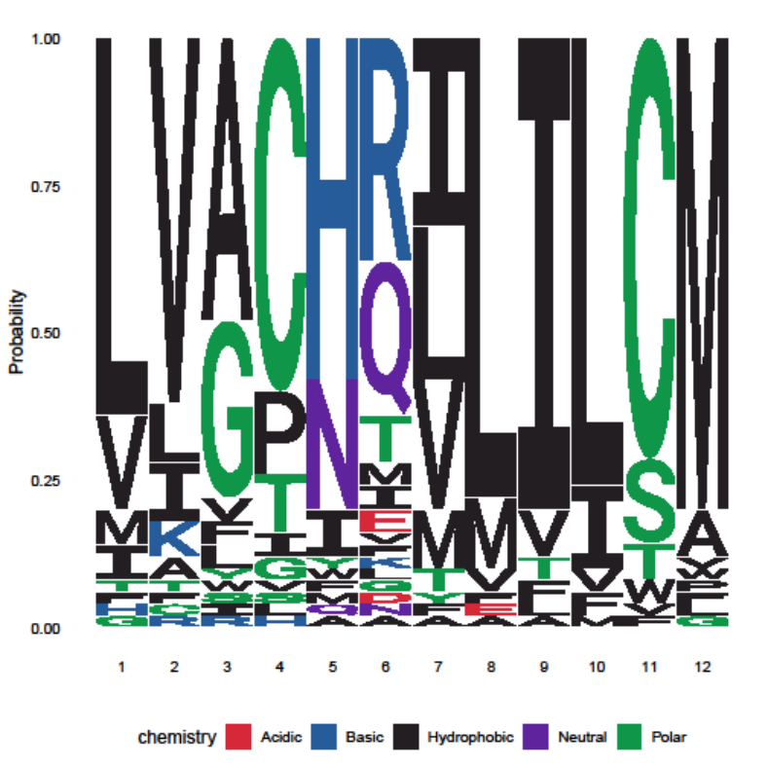
    - Channel logo B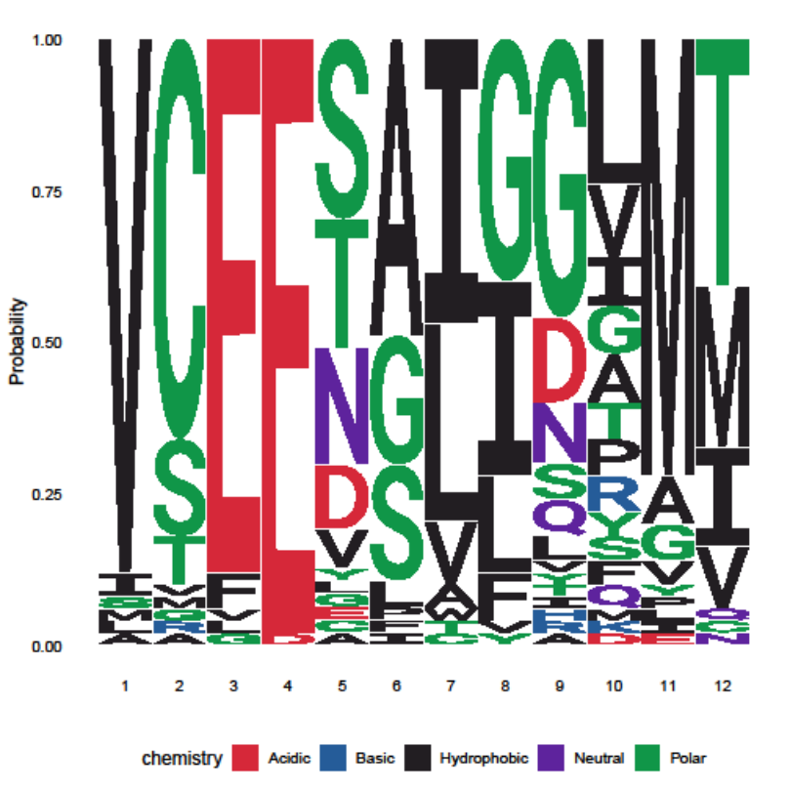
    - There are more of these 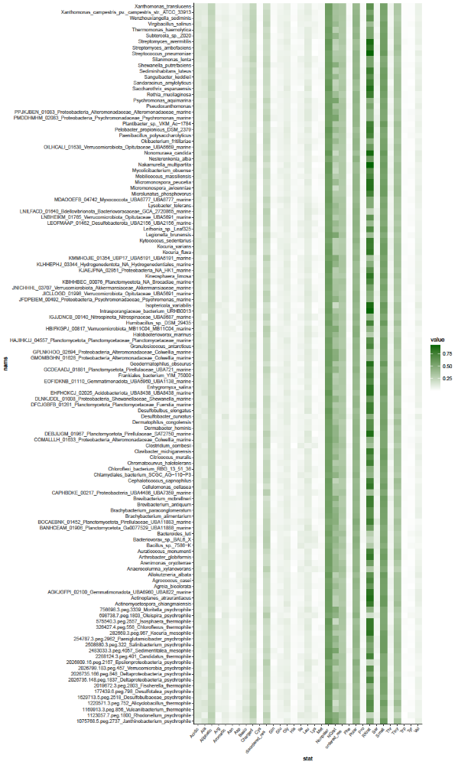
    - 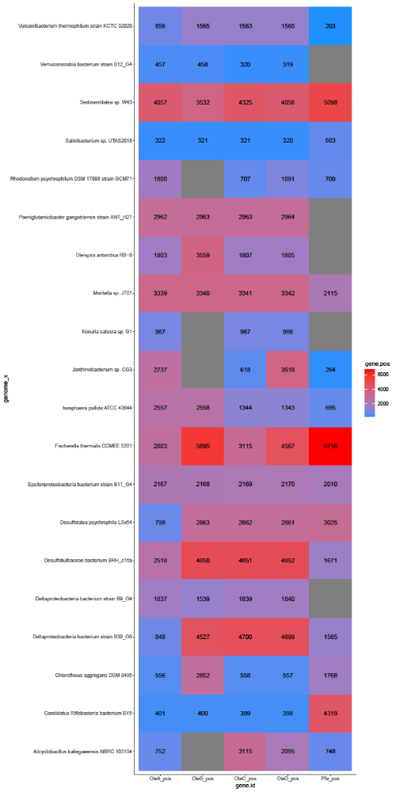
  - Machine learning
    - 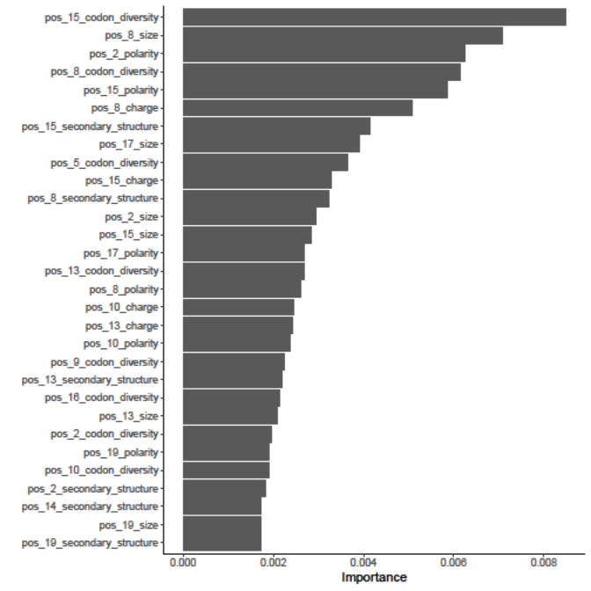
    - Logo of important residues in channel for temperature prediction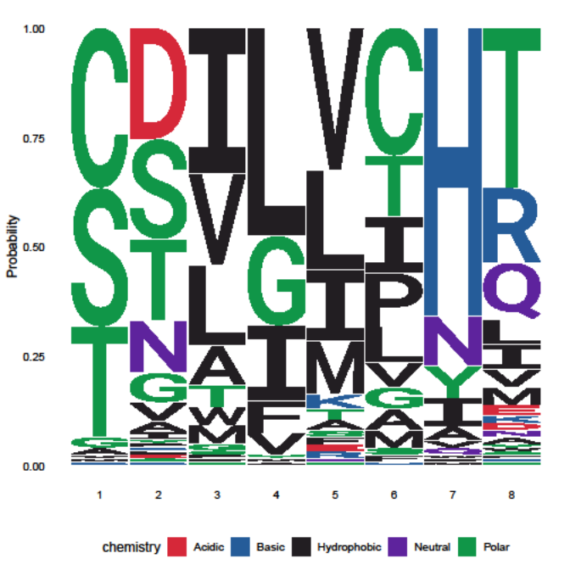
    - Example temperature prediction plot